

BUS USER SUPPORT SYSTEM

DETAIL DESIGN DOCUMENT

Class Design

**Project Code: BUSS**

**Document Code: BUSS_Class_Design_v1.0_EN**

**Ha Noi, 26/06/2015**

Record of change

*A - Added M - Modified D – Deleted

|  |  |  |  |  |
| --- | --- | --- | --- | --- |
| **Effective Date** | **Changed Items** | **A* M, D** | **Change Description** | **New Version** |
| 26/06/2015 | Add new | A | Add this document | v1.0 |
|  |  |  |  |  |
|  |  |  |  |  |

SIGNATURE PAGE

**ORIGINATOR:** Pham Tien Dat 26/06/2014

Developer

**REVIEWERS:**

**APPROVAL:** Nguyen Van Sang

Supervisor

TABLE OF CONTENTS

1 Introduction 6

1.1 Purpose 6

1.2 Definitions, Acronyms and Abbreviations 6

2 Packages 7

2.1 Account management Package 8

2.1.1 Class diagram 8

2.1.2 AccountManagementModel class 8

2.1.3 AccountManagementController 9

2.1.4 Account management Sequence Diagram 10

2.2 Common Package 11

2.2.1 Class diagram 11

2.2.2 CommonModel class 12

2.2.3 CommonController class 12

2.2.4 Sequence Diagram 12

2.3 Bus Package 13

2.3.1 Class diagram 13

2.3.2 BusModel class 14

2.3.3 BusController class 14

2.3.4 Sequence diagram 15

2.4 Path Finder Package 16

2.4.1 Class diagram 16

2.4.2 PathFinderModel class 16

2.4.3 PathFinderController class 17

2.4.4 Sequence Diagram 17

2.5 Reminder Package 19

2.5.1 Class diagram 19

2.5.2 ReminderModel class 19

2.5.3 ReminderController class 20

2.5.4 Sequence Diagram 20

2.6 Track Package 21

2.6.1 Class diagram 21

2.6.2 TrackModel class 22

2.6.3 TrackController class 22

2.6.4 Sequence Diagram 22

2.7 Favorite Package 23

2.7.1 Class diagram 23

2.7.2 FavoriteModel class 23

2.7.3 FavoriteController class 24

2.7.4 Sequence Diagram 24

3 MVC model 26

# Introduction

## Purpose

Bus user support system class design document contains descriptions of all classes of the Bus user support system. It includes:

* Class diagrams that describe the static relation of all classes in the system.

## Definitions, Acronyms and Abbreviations

|  |  |  |
| --- | --- | --- |
| Abbreviations | Description | Comment |
| MVC | Model View Control model |  |
| BUSS | Bus User Support System |  |

# Packages

|  |  |  |  |
| --- | --- | --- | --- |
| No | Package | Language | Description |
| 1. 01 | Common | Java, XML | Store all information search |
|  | Account management | Java, XML | Store all information user and action as : registration, login, log out, viewprofile… |
|  | Bus | Java, XML | Contribution (database, opinion,Q&A) |
|  | Path finder | Java, XML | Do test and Reading document |
|  | Reminder | Java, XML | Manage to admin (add, delete, edit) |
|  | Track | Java, XML | Manage to member (ban/unban,detele) |
|  | Favorite | Java, XML | Store all information of Vocabulary. |

## Account management Package

### Class diagram

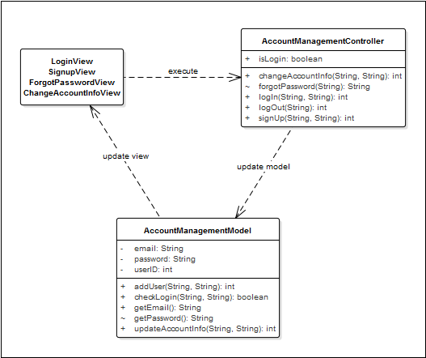

**Figure 1: Class diagram Account mangement package**

|  |  |  |
| --- | --- | --- |
| No | Class Name | Description |
| 1 | AccountManagementModel | Include method interact with database |
| 2 | AccountManagementController | Include method interact with model |

### AccountManagementModel class

#### Attributes

|  |  |  |  |  |  |
| --- | --- | --- | --- | --- | --- |
| No | Attribute | Type | Default | Note | Description |
| 1. 1 | userID | Number |  | private |  |
| 1. 2 | email | String |  | private |  |
| 1. 3 | password | String |  | private |  |

#### Methods

|  |  |  |
| --- | --- | --- |
| No | Method | Description |
|  | addUser() | Interact with database: add a new user. |
|  | checkLogin() | Interact with database: check if email and password inputted match with database or not |
|  | getEmail() | Interact with database: get user’s email |
|  | getPassword() | Interact with database: get user’s password |
|  | updateAccountInfo() | Interact with database: update user account info |

### AccountManagementController

#### Attributes

|  |  |  |  |  |  |
| --- | --- | --- | --- | --- | --- |
| No | Attribute | Type | Default | Note | Description |
| 1 | isLogin | Boolean |  | package |  |

#### Methods

|  |  |  |
| --- | --- | --- |
| No | Method | Description |
|  | changeAccountInfo() | Interact with model to change account info in database |
|  | forgotPassword() | Interact with model to get password from database and send to user’s email |
|  | logIn() | Interact with model to check if user input validated data to log in or not and let them log in. |
|  | logOut() | Log user out of the application |
|  | signUp() | Interact with model to create new user in database and let user sign up. |

### Account management Sequence Diagram

#### UC001_LogIn

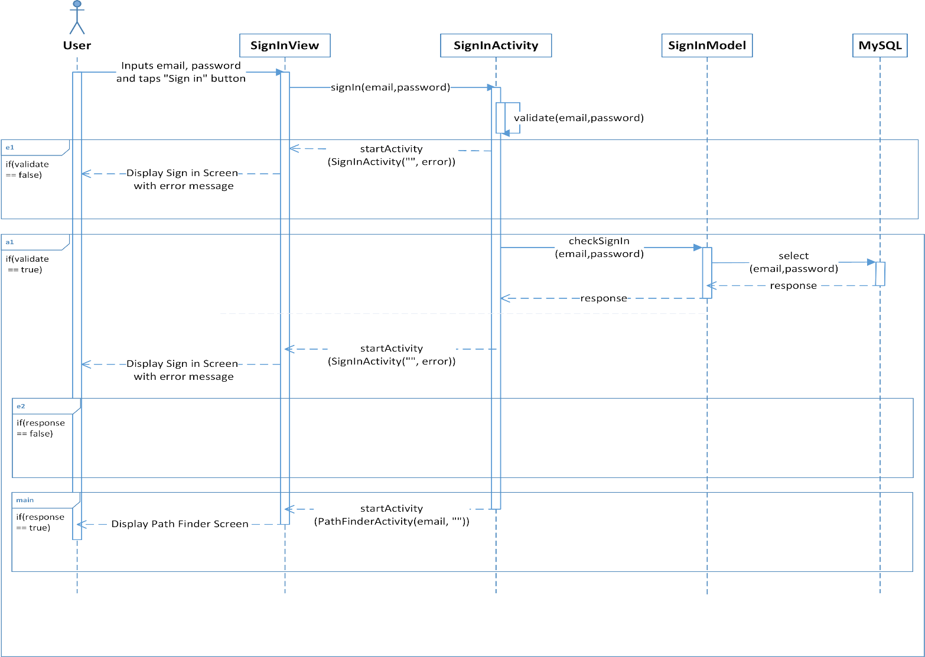

#### UC002_SignUp

#### UC003_LogOut

#### UC004_ForgotPassword

#### UC005_ChangeAccountInfo

## Common Package

### Class diagram

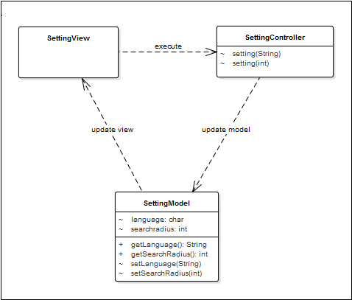

**Figure 2: Class diagram common package**

|  |  |  |
| --- | --- | --- |
| No | Class Name | Description |
| 1 | SettingModel | Include method interact with database |
| 2 | SettingController | Include method interact with model |

### CommonModel class

#### Attributes

|  |  |  |  |  |  |
| --- | --- | --- | --- | --- | --- |
| No | Attribute | Type | Default | Note | Description |
| 1 | language | String |  | Package |  |
| 2 | searchradius | Number |  | Package |  |

#### Methods

|  |  |  |
| --- | --- | --- |
| No | Method | Description |
|  | getLanguage() | Interact with database: get language info |
|  | getSearchRadius() | Interact with database: get search radius info |
|  | setLanguage() | Interact with database: set language |
|  | setSearchRadius() | Interact with database: set search radius |

### CommonController class

#### Attributes

|  |  |  |  |  |  |
| --- | --- | --- | --- | --- | --- |
| No | Attribute | Type | Default | Note | Description |

#### Methods

|  |  |  |
| --- | --- | --- |
| No | Method | Description |
|  | setting(String) | Set language |
|  | setting(int) | Set search radius |

### Sequence Diagram

#### UC006_Change app setting

## Bus Package

### Class diagram

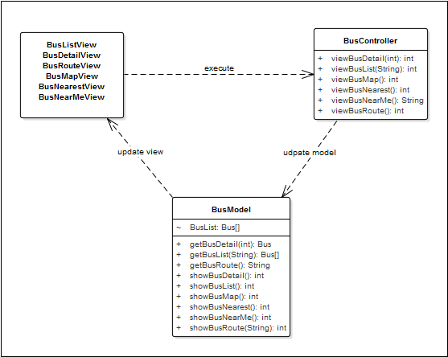

**Figure 3: Class diagram Contact package**

|  |  |  |
| --- | --- | --- |
| No | Class Name | Description |
| 1 | BusModel | Include method interact with database |
| 2 | BusController | Include method interact with model |

### BusModel class

#### Attributes

|  |  |  |  |  |  |
| --- | --- | --- | --- | --- | --- |
| No | Attribute | Type | Default | Note | Description |
| 1 | busList | Bus[] |  | package |  |

#### Methods

|  |  |  |
| --- | --- | --- |
| No | Method | Description |
|  | getBusList() | Interact with database: get bus list |
|  | getBusDetail() | Interact with database: get bus detail |
|  | getBusRoute() | Interact with database: get bus route |
|  | showBusDetail() | Notify change to view – show bus detail |
|  | showBusRoute() | Notify change to view – show bus route |
|  | showBusMap() | Notify change to view – show bus map |
|  | showBusNearest() | Notify change to view – show bus nearest |
|  | showBusNearMe() | Notify change to view – show bus near me |

### BusController class

#### Attributes

|  |  |  |  |  |  |
| --- | --- | --- | --- | --- | --- |
| No | Attribute | Type | Default | Note | Description |

#### Methods

|  |  |  |
| --- | --- | --- |
| No | Method | Description |
|  | viewBusList() | View bus list |
|  | viewBusDetail() | View bus detail |
|  | viewBusRoute() | View bus route |
|  | viewBusMap() | View bus map |
|  | viewBusNearest() | View bus nearest |
|  | viewBusNearMe() | View bus near me |

### Sequence diagram

#### UC0007_View bus list

#### UC0008_Search bus in list

#### UC0009_View bus info

#### UC0010_View bus route

#### UC0011_View bus map

#### UC0012_View bus nearest

#### UC0013_View bus near me

## Path Finder Package

### Class diagram

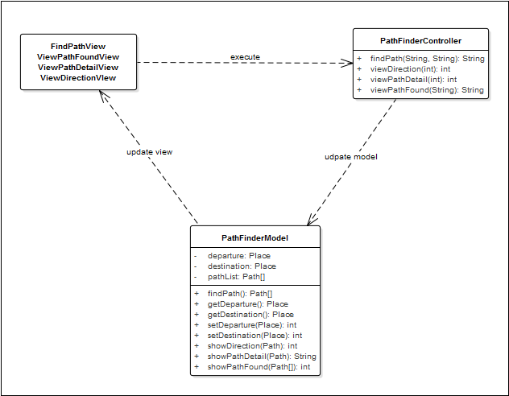

***Figure 4: Class diagram Path finder package***

|  |  |  |
| --- | --- | --- |
| No | Class Name | Description |
| 1 | PathFinderModel | Include method interact with database |
| 5 | PahtFinderController | Include method interact with models |

### PathFinderModel class

#### Attributes

|  |  |  |  |  |  |
| --- | --- | --- | --- | --- | --- |
| No | Attribute | Type | Default | Note | Description |
| 1. 1 | departure | Place |  | private |  |
| 1. 2 | destination | Place |  | private |  |
| 1. 3 | pathList | Path[] |  | private |  |

#### Methods

|  |  |  |
| --- | --- | --- |
| No | Method | Description |
|  | findPath() | Find path |
|  | getDeparture() | Get departure |
|  | getDestination() | Get destination |
|  | setDeparture() | Set departure |
|  | setDestination() | Set destination |
|  | showPathFound() | Show path found |
|  | showPathDetail() | Show path detail |
|  | showDirection() | Show direction |

### PathFinderController class

#### Attributes

|  |  |  |  |  |  |
| --- | --- | --- | --- | --- | --- |
| No | Attribute | Type | Default | Note | Description |

#### Methods

|  |  |  |
| --- | --- | --- |
| No | Method | Description |
| 1 | findPath() | Find path |
| 2 | viewPathFound() | View path found |
| 3 | viewPathDetail() | View path detail |
| 4 | viewDirection() | View direction |

### Sequence Diagram

#### UC0014_Find path

#### UC0015_View path found

#### UC0016_View path detail

#### UC0017_View direction

## Reminder Package

### Class diagram

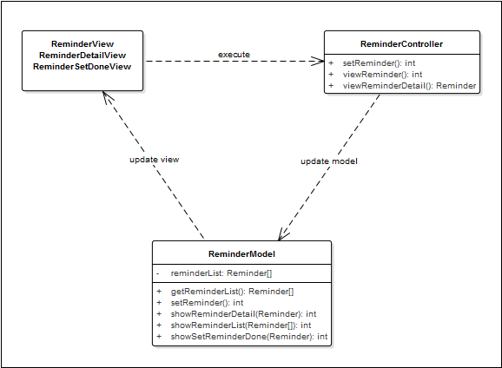

**Figure 5: Class diagram Reminder package**

|  |  |  |
| --- | --- | --- |
| No | Class Name | Description |
| 1 | ReminderModel | Include method interact with database |
| 2 | ReminderController | Include method interact with model |

### ReminderModel class

#### Attributes

|  |  |  |  |  |  |
| --- | --- | --- | --- | --- | --- |
| No | Attribute | Type | Default | Note | Description |
| 1 | reminderList | Reminder[] |  | private |  |

#### Methods

|  |  |  |
| --- | --- | --- |
| No | Method | Description |
|  | getReminderList() | Interact with database: get reminder list |
|  | setReminder() | Interact with database: set a reminder (add/edit/delete/suspend) |
|  | showReminderList() | Notify change to view – show reminder list |
|  | showReminderDetail() | Notify change to view – show reminder detail |
|  | showReminderSetDone() | Notify change to view – show reminder set done |

### ReminderController class

#### Attributes

|  |  |  |  |  |  |
| --- | --- | --- | --- | --- | --- |
| No | Attribute | Type | Default | Note | Description |

#### Methods

|  |  |  |
| --- | --- | --- |
| No | Method | Description |
|  | setReminder() | Set a reminder (add/edit/delete/suspend) |
|  | viewReminder() | View reminder list |
|  | viewReminderDetail() | View reminder detail |

### Sequence Diagram

#### UC0018_View bus reminder

#### UC0019_Add reminder

#### UC0020_Edit reminder

#### UC0021_Delete reminder

#### UC0022_ Suspend/Unsuspend all reminder

#### UC0023_ Suspend/Unsuspend a chosen reminder

## Track Package

### Class diagram

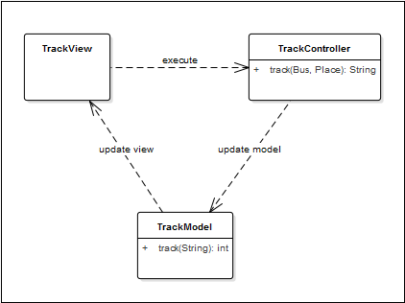

**Figure 6: Class diagram Management member package**

|  |  |  |
| --- | --- | --- |
| No | Class Name | Description |
| 1 | TrackModel | Include method interact with database |
| 2 | TrackController | Include method interact with model |

### TrackModel class

#### Attributes

|  |  |  |  |  |  |
| --- | --- | --- | --- | --- | --- |
| No | Attribute | Type | Default | Note | Description |

#### Methods

|  |  |  |
| --- | --- | --- |
| No | Method | Description |
|  | track() | Interact with database: set track and track bus(es) |

### TrackController class

#### Attributes

|  |  |  |  |  |  |
| --- | --- | --- | --- | --- | --- |
| No | Attribute | Type | Default | Note | Description |

#### Methods

|  |  |  |
| --- | --- | --- |
| No | Method | Description |
|  | track() | Track bus(es) |

### Sequence Diagram

#### UC0024_SetTrack

#### UC0025_CancelTrack

## Favorite Package

### Class diagram

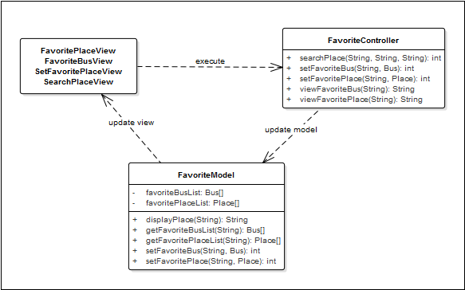

**Figure 7: Class diagram Favorite package**

|  |  |  |
| --- | --- | --- |
| No | Class Name | Description |
| 1 | FavoriteModel | Include method interact with database |
| 2 | FavoriteController | Include method interact with model |

### FavoriteModel class

#### Attributes

|  |  |  |  |  |  |
| --- | --- | --- | --- | --- | --- |
| No | Attribute | Type | Default | Note | Description |
| 1 | favoriteBusList | Bus[] |  | private |  |
| 2 | favoritePlaceList | Place[] |  | private |  |

#### Methods

|  |  |  |
| --- | --- | --- |
| No | Method | Description |
| 1 | displayPlace() | Notify change to view – display found place |
| 2 | getFavoriteBus() | Interact with database: get favorite bus |
| 3 | getFavoritePlac() | Interact with database: get favorite place |
| 4 | setFavoriteBus() | Interact with database: set favorite bus |
| 5 | setFavoritePlace() | Interact with database: set favorite place |

### FavoriteController class

#### Attributes

|  |  |  |  |  |  |
| --- | --- | --- | --- | --- | --- |
| No | Attribute | Type | Default | Note | Description |

#### Methods

|  |  |  |
| --- | --- | --- |
| No | Method | Description |
|  | searchPlace() | Search place |
|  | viewFavoriteBus() | View favorite bus |
|  | viewFavoritePlac() | Get favorite place |
|  | setFavoriteBus() | Set favorite bus |
|  | setFavoritePlace() | Set favorite place |

### Sequence Diagram

#### UC0026_View favorite place

#### UC0027_ Add favorite place

#### UC0028_ Edit favorite place

#### UC0029_ Delete favorite place

#### UC0030_Search favorite place

#### UC0031_View favorite bus

#### UC0032_Add favorite bus

#### UC0033_Delete favorite bus

#### UC0033_ Search favorite bus

# MVC model

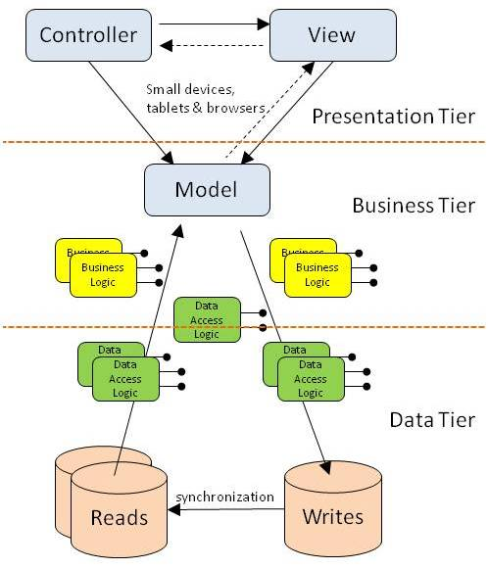

***Figure 6: MVC Model***